[**How to Perform Multivariate Outlier Detection in Python PyOD for Machine Learning | by Bex T. | Towards Data Science**](https://towardsdatascience.com/how-to-perform-multivariate-outlier-detection-in-python-pyod-for-machine-learning-b0a9c557a21c)

[pyod/Compare All Models.ipynb at master · yzhao062/pyod · GitHub](https://github.com/yzhao062/pyod/blob/master/notebooks/Compare%20All%20Models.ipynb)

[What is Outlier | PyOD For Outlier Detection in Python (analyticsvidhya.com)](https://www.analyticsvidhya.com/blog/2019/02/outlier-detection-python-pyod/)

[Examples - pyod 1.0.9 documentation](https://pyod.readthedocs.io/en/latest/example.html)

[Anomaly Detection for Dummies. Unsupervised Anomaly Detection for… | by Susan Li | Towards Data Science](https://towardsdatascience.com/anomaly-detection-for-dummies-15f148e559c1)

[pyod/Compare All Models.ipynb at master · yzhao062/pyod · GitHub](https://github.com/yzhao062/pyod/blob/master/notebooks/Compare%20All%20Models.ipynb)

Multivariate anomaly detection is the process of identifying unusual or interesting occurrences in multivariate data. [Multivariate anomalies occur when the values of various features, taken together seem anomalous even though the individual features do not take unusual values **1**](https://towardsdatascience.com/anomaly-detection-in-python-part-2-multivariate-unsupervised-methods-and-code-b311a63f298b). There are several Python libraries and algorithms available for detecting outlying data points in multivariate data. [One such library is **PyOD**, which is a comprehensive and scalable Python toolkit for detecting outlying objects in multivariate data **2**](https://towardsdatascience.com/pyod-a-unified-python-library-for-anomaly-detection-3608ec1fe321)[**3**](https://towardsdatascience.com/introducing-anomaly-outlier-detection-in-python-with-pyod-40afcccee9ff). [Some of the algorithms used for multivariate anomaly detection include **Mahalanobis Distance**, **One-Class SVM**, and **Isolation Forests** **4**](https://medium.com/analytics-vidhya/anomaly-detection-in-python-part-1-basics-code-and-standard-algorithms-37d022cdbcff).

**Detecting a Multivariate Outlier involves examining the values of all the features simultaneously and verifying if the combination of values taken by the features is unusual.**

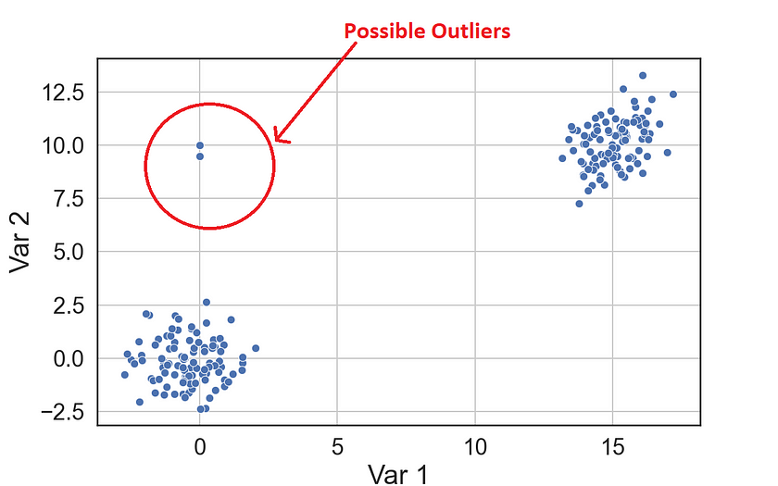

There are several techniques available for multivariate anomaly detection using Python. [Some of the widely used methods include **Isolation Forests**, **OC-SVM (One-Class SVM)**, and **Mahalanobis Distance** **1**](https://towardsdatascience.com/anomaly-detection-in-python-part-2-multivariate-unsupervised-methods-and-code-b311a63f298b). [Another resource for multivariate anomaly detection is the **PyOD** library, which is a comprehensive and scalable Python toolkit for detecting outlying objects in multivariate data **2**](https://towardsdatascience.com/pyod-a-unified-python-library-for-anomaly-detection-3608ec1fe321)[**3**](https://towardsdatascience.com/introducing-anomaly-outlier-detection-in-python-with-pyod-40afcccee9ff). [PyOD includes more than 30 different algorithms for detecting outlying data points in multivariate data](https://towardsdatascience.com/introducing-anomaly-outlier-detection-in-python-with-pyod-40afcccee9ff)